Instructions:
- Review the schema, sample data, and table planning charts.
- Create the SQL statements and create the database in Oracle.

Entity Relationship Diagram
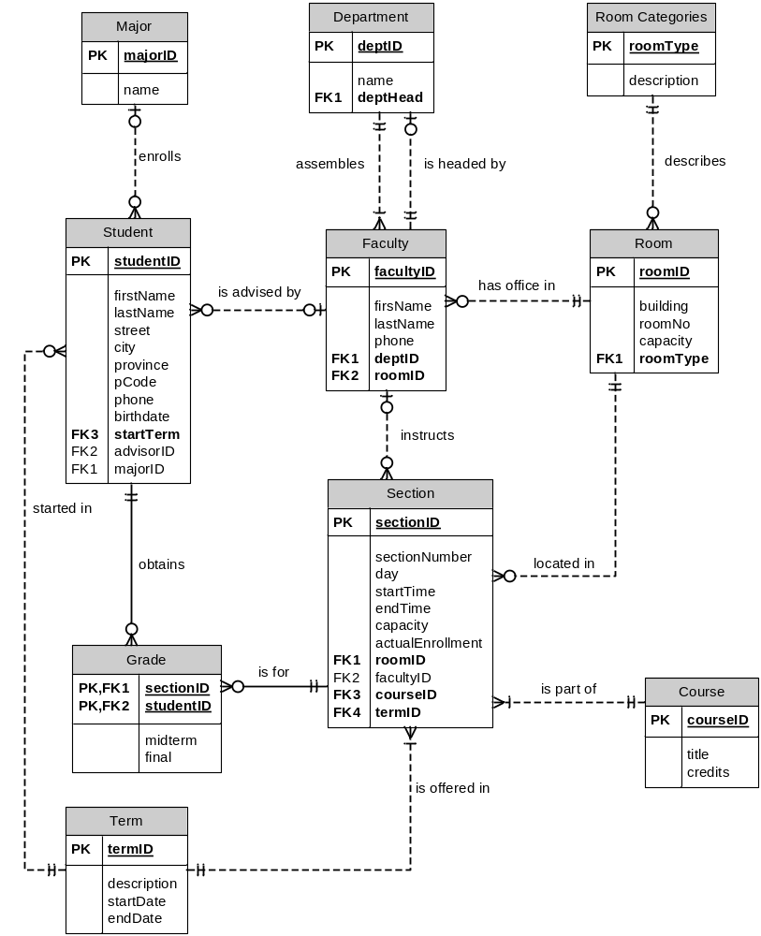

Sample Data

Major
MajorID | name
100 | AAS-Accounting
200 | AAS-Computer Science
300 | AAS-Telecommunications
400 | BS-Accounting
500 | BS-Computer Science
600 | BS-Telecommunications

Department
deptID | name | deptHead
1 | Computer Science | 111
2 | Telecommunications | 222
3 | Accounting | 333
4 | Math & Science | 444
5 | Liberal Arts | 555

Room Categories
RoomType | description
L | Lab
C | Classroom
O | Office

Student
studentID | lastName | firstName | street | city | province | pCode | startTerm | birthDate | advisorID | majorID | phone
00100 | Diaz | Jose | 1 Ford Avenue #7 | Saskatoon | SK | S7K3E4 | WN00 | 02/12/1980 | 123 | 100 | 9735551111
00101 | Tyler | Mickey | 12 Morris Avenue | Regina | SK | S6T5R6 | SP00 | 03/18/1979 | 555 | 500 | 7185552222
00102 | Patel | Rajesh | 25 River Road #3 | Edison | SK | S9O8U7 | WN00 | 12/12/1982 | 111 | 400 | 7325553333
00103 | Rickles | Deborah | 100 Main Street | Edmonton | AB | A6G4T5 | FL00 | 10/20/1970 | 55 | 500 | 7325554444
00104 | Lee | Brian | 2845 First Lane | Saskatoon | SK | S7K3D5 | WN00 | 11/28/1975 | 345 | 600 | 2125555555
00105 | Khan | Amir | 213 Broadway | Saskatoon | SK | S7K3F4 | WN00 | 07/07/1981 | 222 | 200 | 2017585555

Faculty
facultyID | firstName | lastName | roomID | phone | deptID
111 | Fred | Jones | 11 | 525 | 1
222 | Bill | Williams | 20 | 533 | 2
123 | Alice | Mobley | 11 | 529 | 1
235 | Lee | Vajpayee | 12 | 577 | 2
345 | Vi | Sen | 12 | 579 | 3
444 | Brenda | Rivera | 21 | 544 | 4
555 | Mea | Chang | 17 | 587 | 5
333 | Andrea | Collins | 17 | 599 | 3

Room
roomID | building | roomNo | capacity | roomType
11 | Gandhi | 101 | 2 | O
12 | Gandhi | 103 | 2 | O
13 | Kennedy | 202 | 35 | L
14 | Kennedy | 204 | 50 | L
15 | Nehru | 301 | 50 | C
16 | Nehru | 309 | 45 | C
17 | Gandhi | 105 | 2 | O
18 | Kennedy | 206 | 40 | L
19 | Kennedy | 210 | 30 | L
20 | Gandhi | 107 | 2 | O
21 | Gandhi | 109 | 2 | O

Grade
studentID | sectionID | midterm | final
00100 | 1101 | C | F
00100 | 1102 | B | B
00100 | 1104 | B | A
00101 | 1102 | F | D
00101 | 1103 | A | A
00103 | 1101 | F | W
00103 | 1104 | D | D
00100 | 1207
00103 | 1206
00104 | 1206
00104 | 1207
00104 | 1210
00105 | 1208
00105 | 1209
00101 | 1205
00102 | 1210
00102 | 1207
00102 | 1206

Section
sectionID | courseID | Section  Number | termID | facultyID | day | startTime | endTime | roomID | capacity | Actual  Enrollment
1101 | CIS265 | 01 | WN01 | 111 | MW | 09:00 | 10:30 | 13 | 30 | 21
1102 | CIS253 | 01 | WN01 | 123 | TR | 09:00 | 10:30 | 18 | 40 | 39
1103 | MA150 | 02 | WN01 | 444 | F | 09:00 | 12:00 | 15 | 25 | 25
1104 | AC101 | 10 | WN01 | 345 | MW | 10:30 | 12:00 | 16 | 35 | 35
1205 | CIS265 | 01 | SP01 |  | MW | 09:00 | 10:30 | 14 | 35 | 12
1206 | CIS265 | 02 | SP01 | 111 | TR | 09:00 | 10:30 | 18 | 30 | 27
1207 | LA123 | 05 | SP01 |  | MW | 09:00 | 10:30 | 15 | 30 | 29
1208 | CIS253 | 21 | SP01 | 123 | TR | 09:00 | 10:30 | 14 | 40 | 40
1209 | CIS253 | 11 | SP01 | 111 | MW | 09:00 | 10:30 | 18 | 40 | 5
1210 | CIS253 | 31 | SP01 | 123 | F | TBA | TBA | 11 | 1 | 1

Course
courseID | title | credits
EN100 | Basic English | 0
LA123 | English Literature | 3
CIS253 | Database Systems | 3
CIS265 | Systems Analysis | 3
MA150 | College Algebra | 3
AC101 | Accounting | 3

Term
termID | description | startDate | endDate
SP00 | Spring 2006 | 05/01/2006 | 08/11/2006
FL00 | Fall 2006 | 09/04/2006 | 12/15/2006
WN01 | Winter 2007 | 01/02/2007 | 04/13/2007
SP01 | Spring 2007 | 04/30/2007 | 08/10/2007
FL01 | Fall 2007 | 09/03/2007 | 12/14/2007

Table Planning

Table: Major
Column | Datatype | Null? | Check | Default | Key | References
majorID | Number(5) | no |  |  | Primary
name | Varchar2(30)

Table: Department
Column | Datatype | Null? | Check | Default | Key | References
deptID | Number(2) | No |  |  | Primary
name | Varchar2(25)
deptHead | Number(3) | No |  |  | Foreign | Faculty(facultyID)

Table: Room Categories
Column | Datatype | Null? | Check | Default | Key | References
roomType | Char(1) | No |  |  | Primary
description | Varchar2(9)

Table: Student
Column | Datatype | Null? | Check | Default | Key | References
studentID | Char(5) | No |  |  | Primary
firstName | Varchar2(10)
lastName | Varchar2(10)
street | Varchar2(20)
city | Varchar2(10)
province | Char(2) |  |  | SK
pCode | Char(6)
phone | Number(10)
startTerm | Char(4) | No |  |  | Foreign | Term(termID)
birthdate | Date
advisorID | Number(3) |  |  |  | Foreign | Faculty(facultyID)
majorID | Number(3) |  |  |  | Foreign | Major(majorID)

Table: Faculty
Column | Datatype | Null? | Check | Default | Key | References
facultyID | Number(3) | No |  |  | Primary
firstName | Varchar2(10)
lastName | Varchar2(10)
phone | Number(3)
roomID | Number(2) | No |  |  | Foreign | Room(roomID)
deptID | Number(1) | No |  |  | Foreign | Department(deptID)

Table: Room
Column | Datatype | Null? | Check | Default | Key | References
roomID | Number(2) | No |  |  | Primary
building | Varchar2(7)
roomNo | Number(3)
capacity | Number(2) |  | >0
roomType | Char(1) | No |  |  | Foreign | Room Categories(roomType)

Table: Grade
Column | Datatype | Null? | Check | Default | Key | References
studentID | Char(5) | No |  |  | Composite | Student(studentID)
sectionID | Number(4) | No |  |  | Composite | Section(sectionID)
midterm | Char(1)
final | Char(1)

Table: Section
Column | Datatype | Null? | Check | Default | Key | References
sectionID | Number(4) |  |  |  | Primary
sectionNumber | Number(2)
day | Char(2) |  | MW OR TR OR F
startTime | Date
endTime | Date
capacity | Number(2) |  | >=0
actualEnrollment | Number(2) |  | >=0
courseID | Char(4) | No |  |  | Foreign | Course(courseID)
termID | Char(6) | No |  |  | Foreign | Term(termID)
facultyID | Number(3) | No |  |  | Foreign | Faculty(facultyID)
roomID | Number(2) | No |  |  | Foreign | Room(roomID)

Table: Course
Column | Datatype | Null? | Check | Default | Key | References
courseID | Char(6) | No |  |  | Primary
title | Varchar2(25)
credits | Number(1) |  | >=0 | 3

Table: Term
Column | Datatype | Null? | Check | Default | Key | References
termID | Char(4) | No |  |  | Primary
description | Varchar2(15)
startDate | Date
endDate | Date

